We are creating 1 domain controller and 2 Prod VMs

Same resource group, availability set

**Configuration changes**

* Change the IP addresses from dynamic to static
* On the VNET register the DC VM’s IP address

Changing dynamic to static

Step 1: Open the VM

Step 2 click “Network setting”

Step 3 click NIC

See here – Click IPConfig

Select Static and Save

DO THIS TO ALL MACHINES

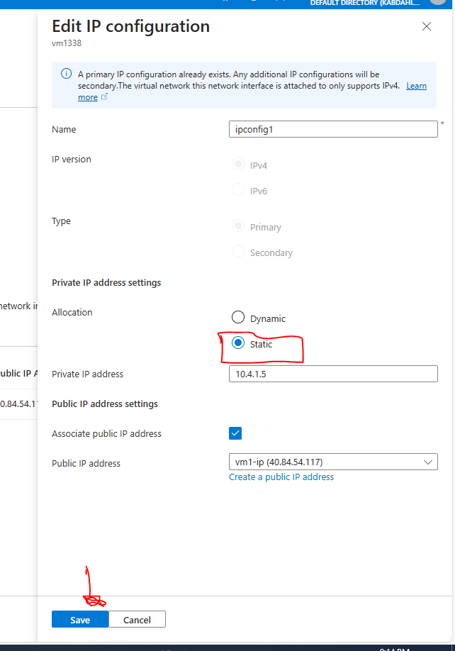

Adding the DC Ipv4 IP address to DNS server

Open the VNET

Copy the DC VM IP and Add custom DNS

